Calculating Carbon Intensity of Electricity

Carbon intensity of electricity is calculated with an iterative method that propagates embedded emissions along transmission lines according to a given dispatch schedule. Emissions are repeatedly propagated until an additional iteration alters the net emissions less than one percent. The diagram below illustrates a simplified dispatch schedule where storage’s energy balance occurs over two timepoints. Notice that energy can flow through storage from timepoints 1 to 2 (node A) and can flow backwards from timepoints 2 to 1 (node E). Storage conducts an energy balance over a typical day that repeats, so E’s storage schedule can be interpreted storing energy in the evening and releasing it the next morning.

Our RPS implementation divides power into renewable and non-renewable stocks that remain distinct from generation source, through transmission, storage and intermediate load areas to its final destination. For purposes of tracking the stocks of power and embedded emissions, we can consider dispatch of non-RPS power completely separately from RPS power. The diagram illustrates the dispatch of non-RPS power.

The following terms are used in these calculations:
P_{gross} : The total power available to a node that can be consumed or sent out. For nodes representing a load area in a given hour, P_{gross} is calculated as the sum of locally generated power, power received from transmission, and power received from storage. For nodes representing a storage project over a day, P_{gross} is calculated as the total power released in a day. Because of inefficiencies, this will be less than the power received in the same day.
P_{net} : The power available to an hourly load area node after some power is sent out. This term is not relevant to daily storage nodes.
P_{x->y} : Power sent from node X to node Y in a given hour.
E_{gen} : Direct emissions from generators in a load area in a given hour. This term is not relevant to daily storage nodes.
E_{x->y} : Embedded emissions sent from node X to node Y along with power in a given hour.
E_{gross} : The sum of direct emissions from generators and embedded emissions received by a node.
E_{net} : A load area’s net emissions in a given hour (gross emissions minus all exported embedded emissions). This can be calculated as E_{gross} • P_{net} / P_{gross} This term is not relevant to daily storage nodes.

With this formulation, E_{gross} and E_{x->y} are defined in terms of each other. The embedded emissions E_{x->y} is calculated as a percentage of the gross emissions of the source node: E_{x->y} = E_{gross,src} • P_{x->y} / P_{gross,src} Conversely, gross emissions are calculated as the sum of direct emissions and all embedded emissions received. We sidestep this circular dependency by making initial estimates, then iteratively recalculating each term with the prior round’s estimates. Initially E_{gross} is E_{gen} for hourly load area nodes and 0 for daily storage nodes. Similarly, E_{x->y} is initially set to 0. At each round, we also calculate the difference in E_{net} and look for convergence. We do not let the process cycle through more than 100 rounds and will exit early if the sum of the differences in all of the nodes’ E_{net} between rounds is less than 1% of the total emissions for the day’s graph. E.g. SUM( ABS( E_{net} - E’_{net} ) ) / SUM(E_{gen} ) < 0.01 In practice, most scenarios reached convergence in 10 rounds, and the slowest convergence required 19 rounds.

The final carbon intensity of electricity in a load area is calculated as the sum of the net emissions across RPS and non-RPS categories divided by the sum of the net power across the same categories.
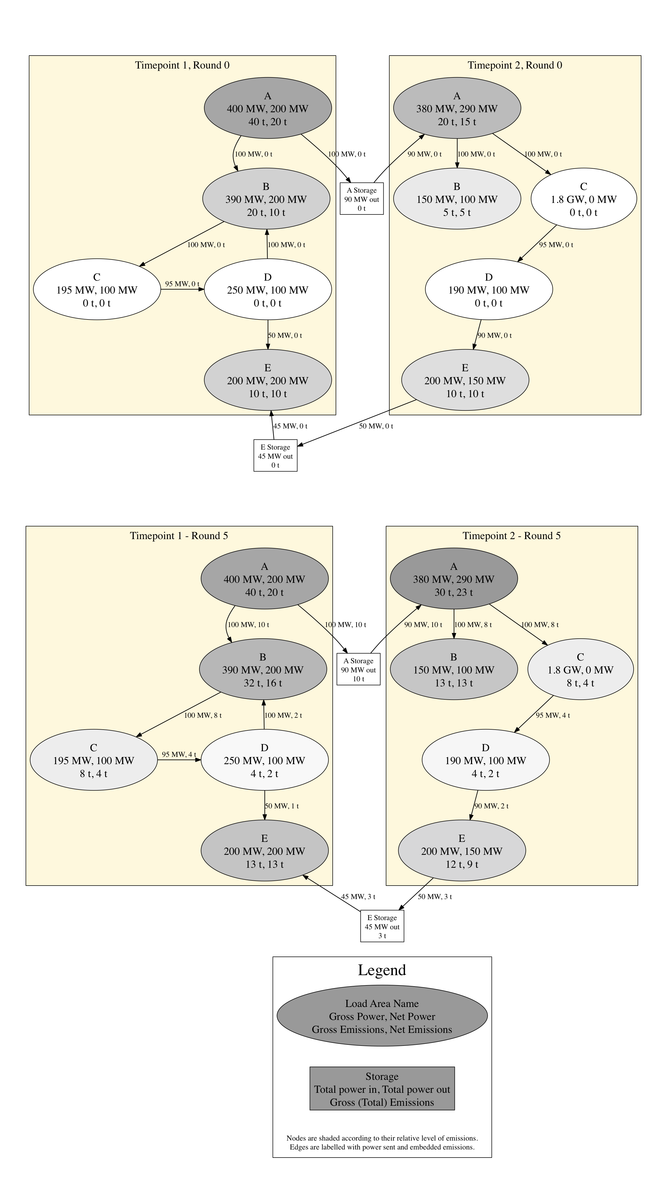
Figure 1 Example dispatch graph of non-RPS power over a day. The top panel shows initial estimates and the bottom panel shows final estimates after 5 rounds. Gross, net, and exported emissions may not add up in the diagram due to rounding the values in the labels (e.g. Load area D, Timepoint 1 in round 5).

